Test site : Staging server (https://bitzer-app.ripplewerkz.co/)
Topic : Adding Data
Priority : Medium

- Client. Worked
Worked fine. After create new client the page will redirect to client list.
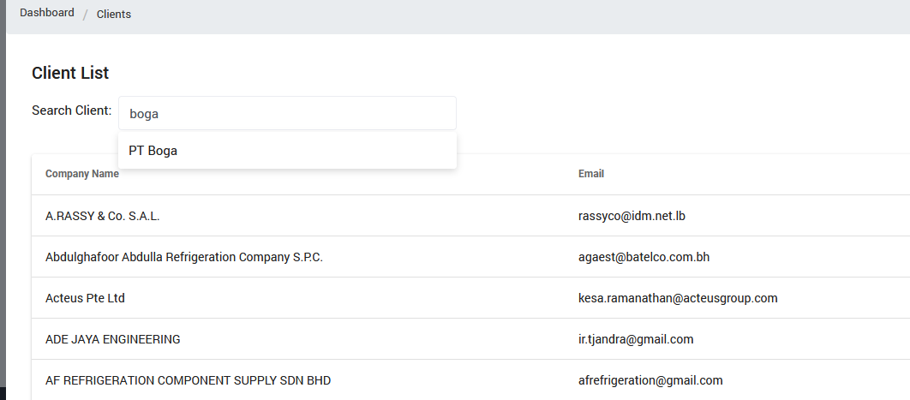

- Factory. Not Worked Properly Major
After click save button, the button is disable and the page not redirect to factory list. But the problem is the factory that I create before not store in factory list.
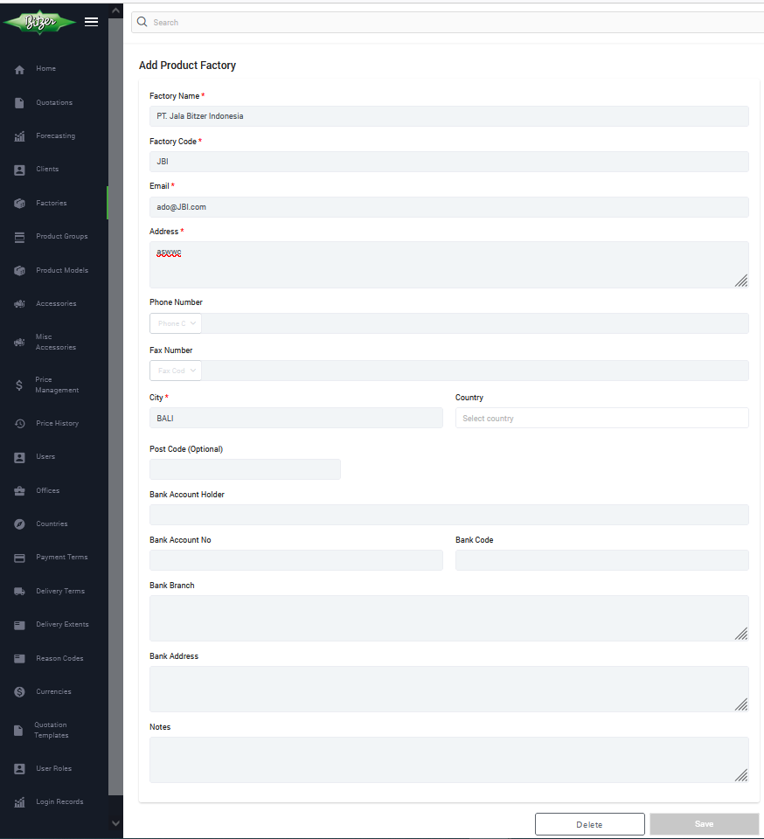
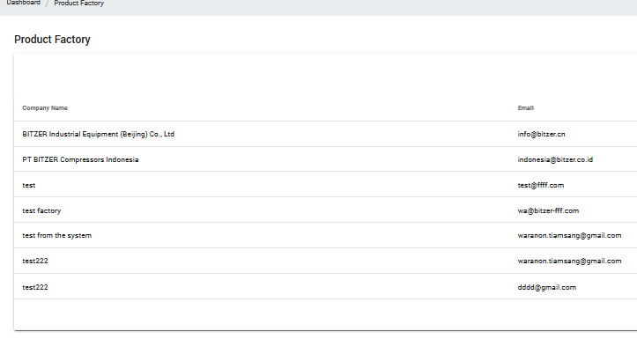

- Product Group. Worked
Worked fine. After Add new Product Group the page will redirect to Product family list.
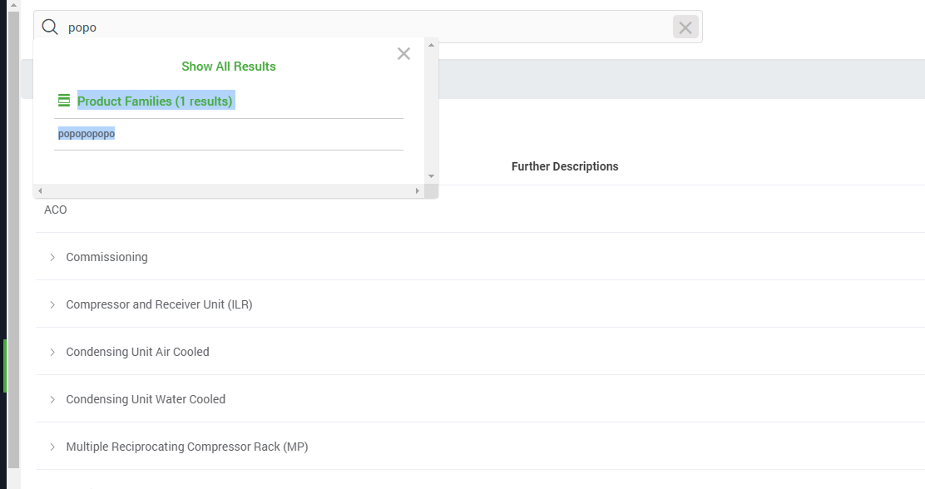
- Product Model. Worked
Work fine. After Add New Product Model the page redirect to product model list.
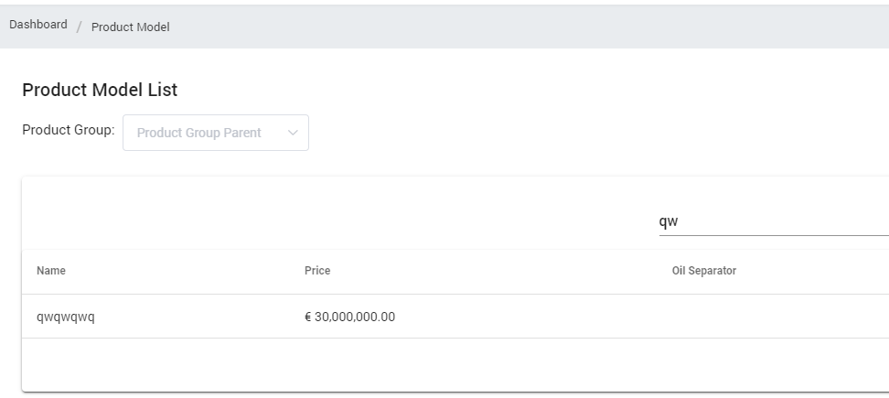

- Accessory. Worked
Work fine. After click Add New Product accessories the page redirect to accessories list.
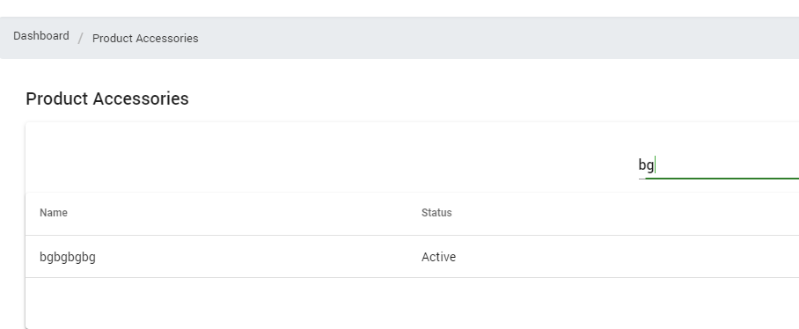
- Misc Accessory. Worked Minor
Work fine. After click Add Misc Accessory wil redirect to the list.
But one minor detail, it’s will be good if the button is match with module name.
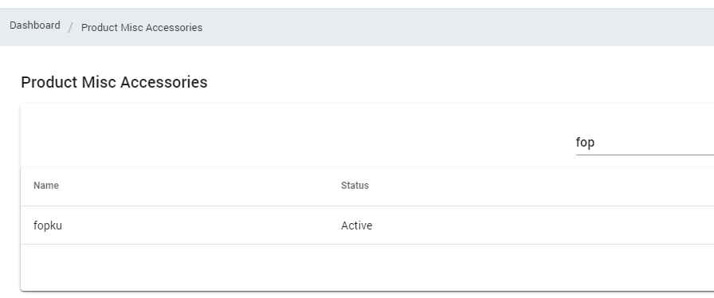
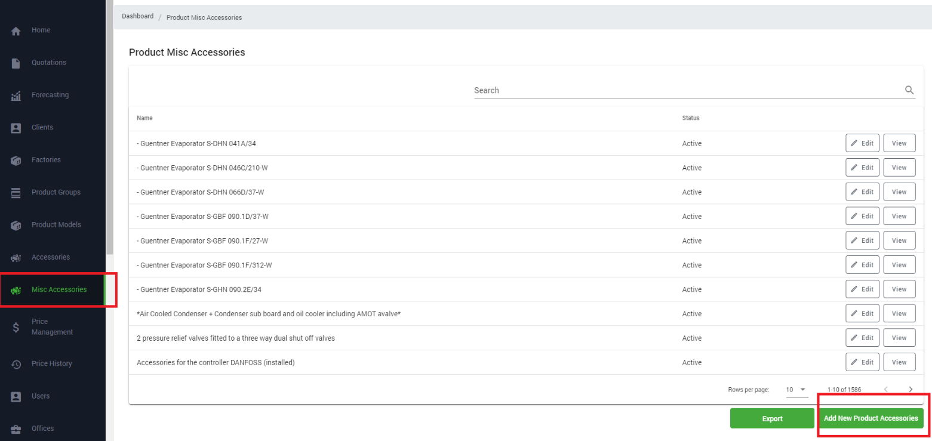
- User. Not Worked Properly Major
After click add New user the button not disable and if we click will show error bellow.
When I update data of user the data wont change and update button not redirect to any where.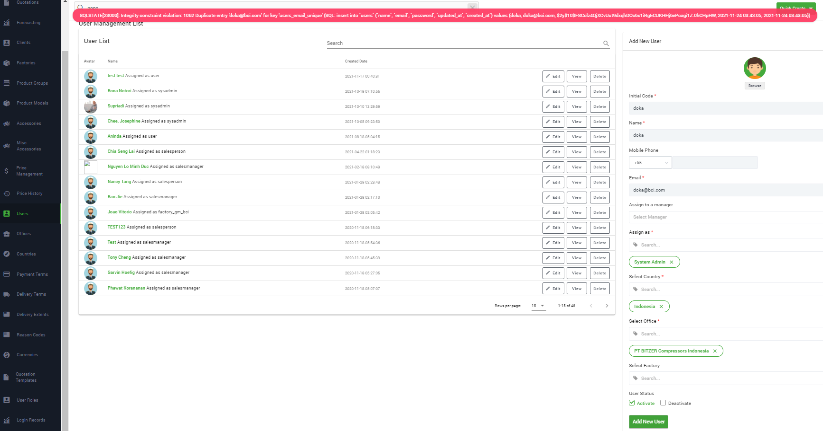
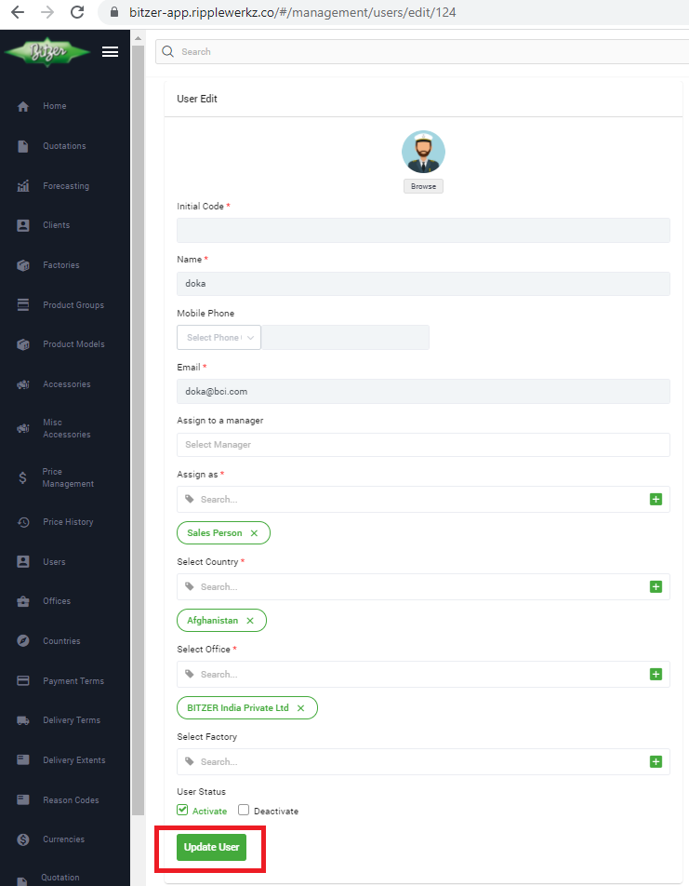
- Offices. Worked
After click add button will redirect to office list.
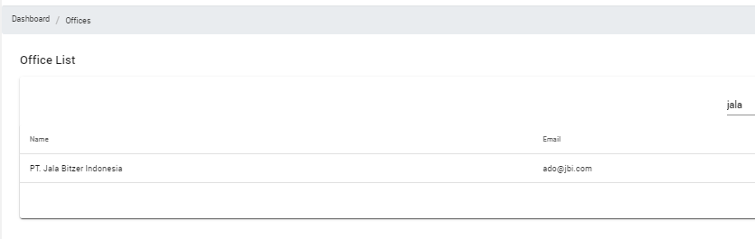
- Countries. Worked
after click add button will redirect to Country list. I create Wakanda as new country.
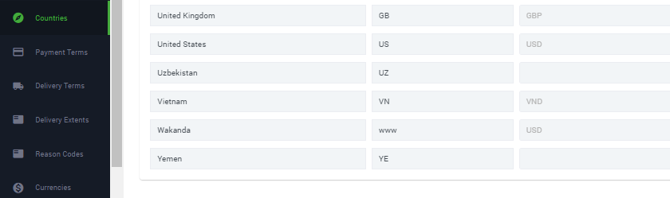
- Payment Terms. Worked
If I click fast fro souple times system will create same payment term (example2 days and 3 days) and also will redirect to Payment Term list.as long as you click once the system will create one payment term to.
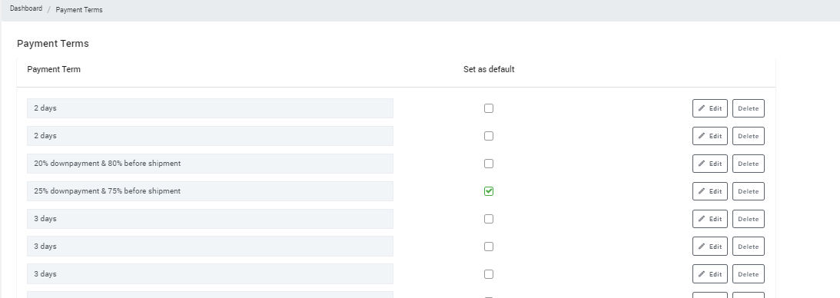
- Delivery Terms. Worked
after click add button will redirect to Delivery Term list.
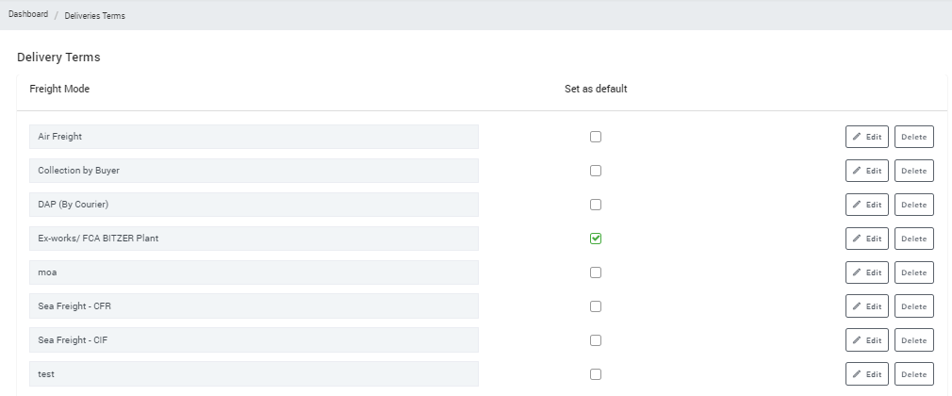
- Delivery Extents. Worked
after click add button will redirect to Delivery Extens list.

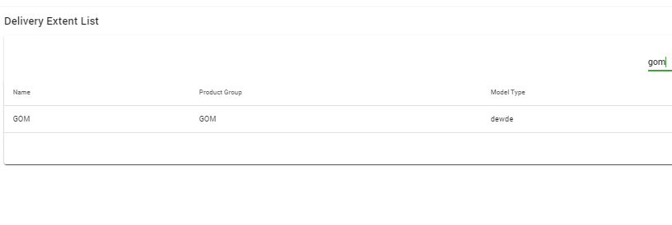
- Reason Codes. Worked Minor
after click add button will redirect to reason code list.
One minor detail, the system still allow alphabet in reason code
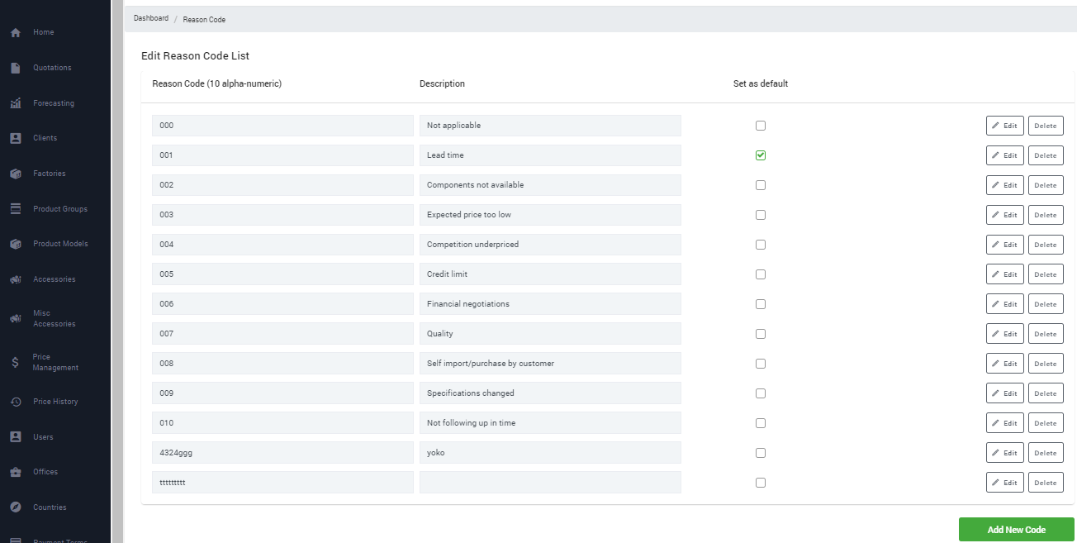
- Currencies. Worked
after click add button will redirect to reason code list.
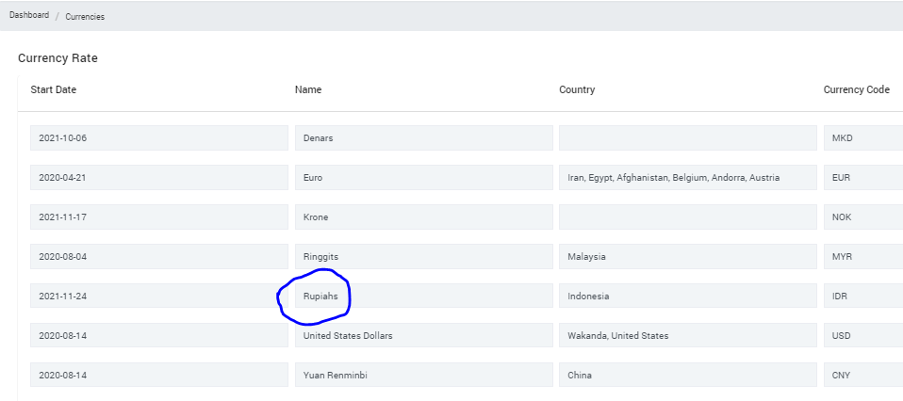
- User Roles. Worked.
after click add button will redirect to User Roles list.
